An Introduction to Parameters in Power BI

Parameters are user-generated values that define how a system can operate. We can use parameters in Power BI to grant users control over visuals in a report, breathing new life into them in the process by making them interactive. You can create and/or interact with parameters in Power BI Desktop and in Power Query. In Power BI Desktop, there are two types of parameters: Numeric parameters or field parameters. Numeric parameters allow users to set specific ranges to filter their data. Field parameters allow users to change the measures analyzed in a report.
Creating a numeric parameter in Power BI Desktop
Modeling -> New Parameter
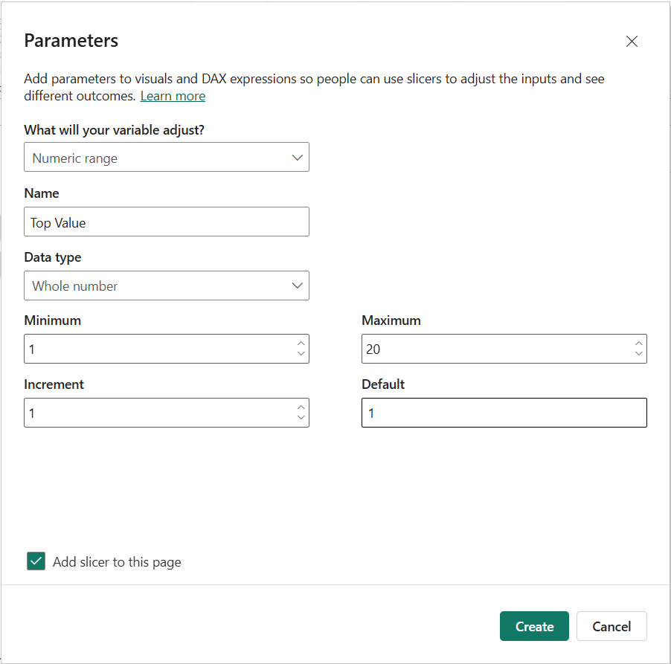
Click on the New Parameter card and then click on Numeric Range in the dropdown. Let’s use a parameter to compare product sales with discounts. Name your parameter ‘Top Value’ and change the Data type to ‘Whole number’. Set the Minimum to 1, Maximum to 20, and Increment to 1. If you want a slicer to be added to your page with your new parameter, keep the ‘Add slicer to page box’ checked.
Now hit Create to have the parameter slicer apply to your current report page. Notice that the parameter now exists in the Data Pane. This is where we’ll drag the field from to populate our visuals. Now, create a table chart visual with Top Sales (after creating this measure) by Country. Try different values in your parameter and see what happens to your visual. Regardless of your parameter selection, your visual won’t change. This is because to connect our parameter to our visuals, we first need to create a custom measure that references the parameter. To create a new measure, click the ‘New measure’ tile in the Home or Modeling tabs.
Once you click on New measure, a popup window will appear at the top of your screen where you are able to use the DAX language to create a custom measure. We will use the following formula for our TopN Country by Sales measure:
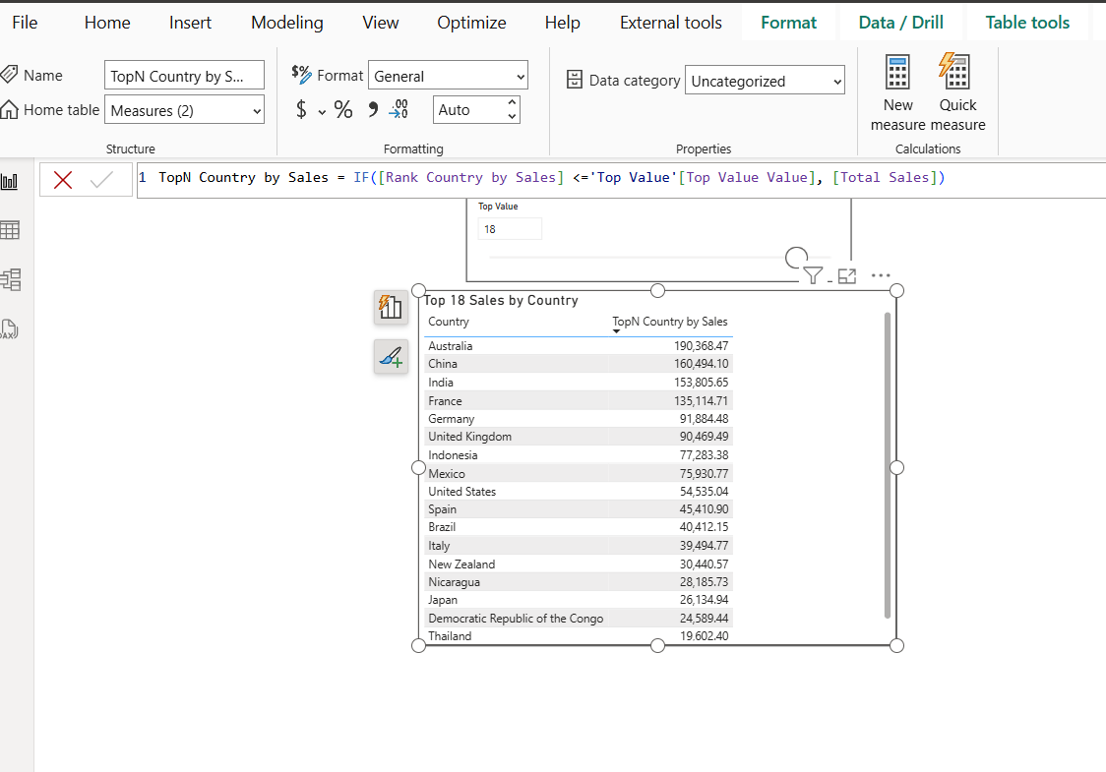

What are Field Parameters?
Field Parameters are a feature that equips users with the ability to toggle between multiple dimensions or values in a data model, thereby changing what is displayed on a visualization. The idea is very simple to Numeric Range Parameters, but instead of just toggling a value, you can now toggle between fields, too.
For example, you could create a field parameter to toggle a visualization that displays Total Profit by Product Category to Profit by Country or any other dimension. You could also create a field parameter that changes the value from Profit to Revenue and use that instead or alongside the other Field Parameter for even more customization.
Why are Field Parameters Important?
Field Parameters are an important feature for a few reasons:
- They provide end-users with the flexibility to easily change either the dimension or measure that a visualization is showing
- They provide an automatic solution to a problem that previously required an expensive workaround
- They are further proof that Microsoft is investing in providing a better user experience for Power BI consumers rather than just investing in backend features.
Tools such as Tableau have had this feature for a while, so this can help Power BI continue to catch up in one of the main areas that it continues to lag, which is the flexibility to customize the user experience. Again, this same functionality was achievable before, but it required the use of complex DAX functions, which took time and expertise. Now, this process is automated.
How to Create a Field Parameter
Now that we understand what Field Parameters are and why they are important, let’s run through a quick example of how to use them in Power BI.
Step 1: Enable Field Parameters in the Preview Features
To enable, click on File on the top left and select Options and Settings followed by Options. You can find the Preview features section near the bottom. Ensure Field parameters are selected, and then click the green OK button (see image below). You will need to save and reopen the Power BI workbook.
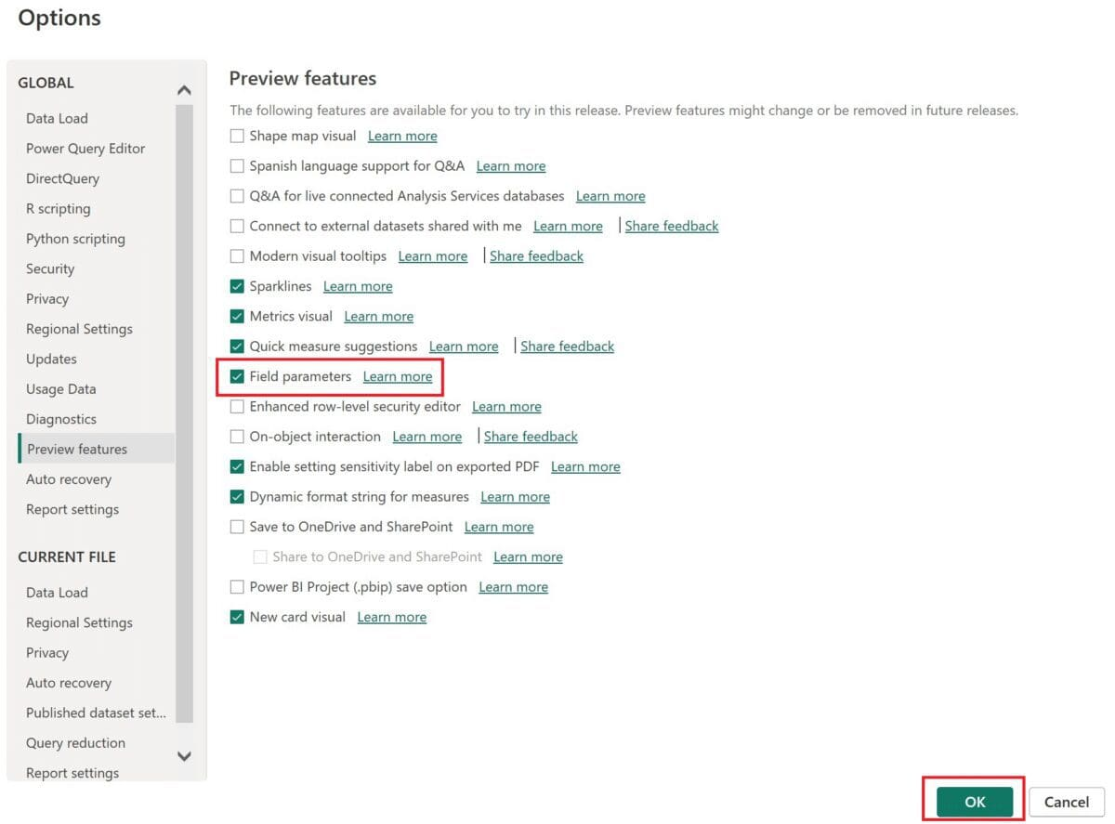
Step 2: Create a Field Parameter
Now that the feature is enabled, you can create a Field Parameter.
Navigate to the Modeling ribbon at the top of your Power BI Desktop screen. Open the New Parameter dropdown section and select Fields.
A popup window will appear. Give your parameter a name (this will be the name of the table that is auto-created after this step).
Now select the fields that you would like to include in the parameter by checking the boxes next to them or by dragging them into the Add and Reorder fields window (the example below uses Category and Sub-Category) and then click the green Create button and leave the Add slicer to this page checkbox selected.
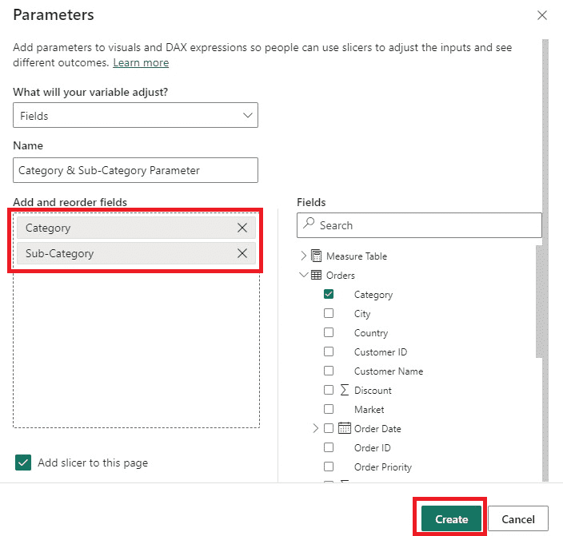
After completing the previous step, you will notice two things:
- A slicer with the field names has been added to the canvas
- A new table with the name of the Field Parameter has been added (select the field parameter to view the DAX). You can edit this DAX to add or remove fields from the parameter.
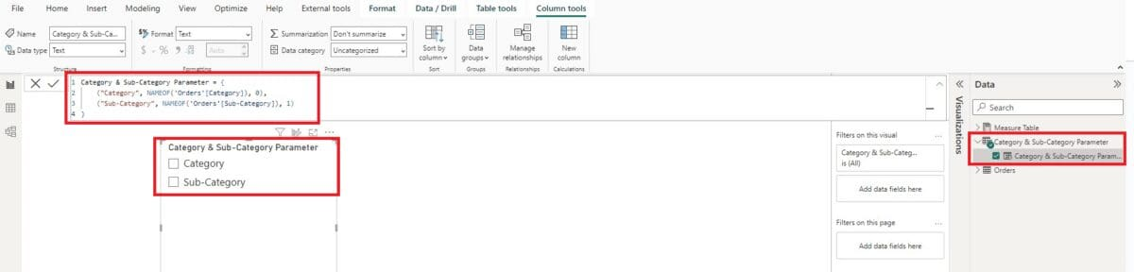
How to Use a Field Parameter
Now that you have created the Field Parameter, you are ready to use it on a visualization.
Add a new visualization to the canvas and select the measure you want to analyze (we’ll use Total Sales in the example). Now, add the Field Parameter that you created in the previous section.
After creating the visualization, you can now toggle between showing Total Sales by Category or Sub-Category using the slicer that was inserted onto the canvas at the end of the previous section (see two screenshots below).
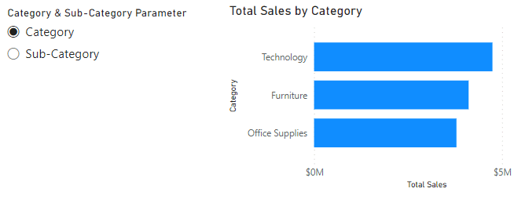
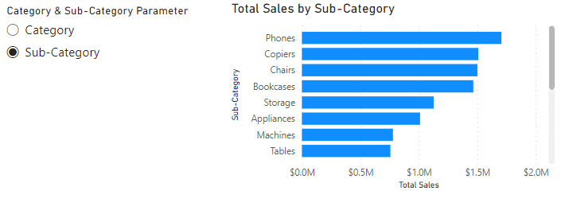
Remember, you can use as many dimensions or measures as you want on a single Field Parameter.
Closing
Now that you know how to create and use Field Parameters in Power BI, it should make toggling between fields much easier for both developers and end-users. Feature improvements like this are an exciting sign that Microsoft is invested in making Power BI’s user experience better for all.

